CSA0503-DATABASE MANAGEMENT SYSTEMS

EXPERIMENT 1 - DDL Commands – CREATE, ALTER, DROP
1) Create a table name STUDENT with following structure.
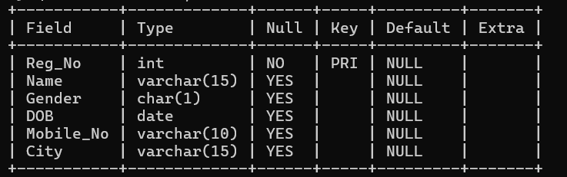
2) Create a table name FACULTY with following structure.
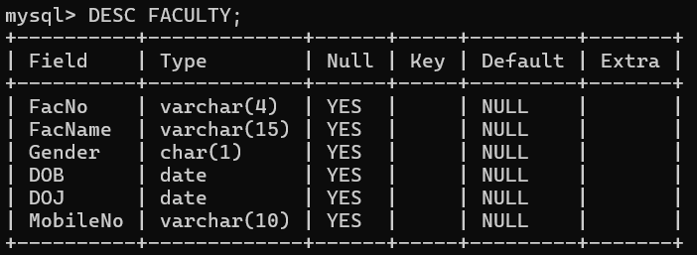
3) Create a table name DEPARTMENT with following structure.
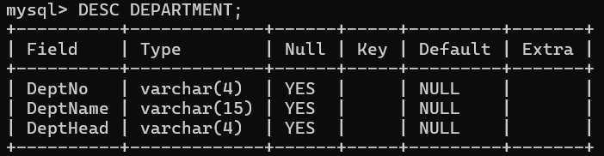

4) Create a table name COURSE with following structure.
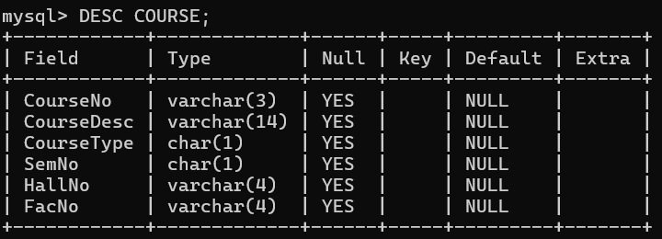
5) Modify the table FACULTY by adding a column name Dept of datatype VARCHAR(10)
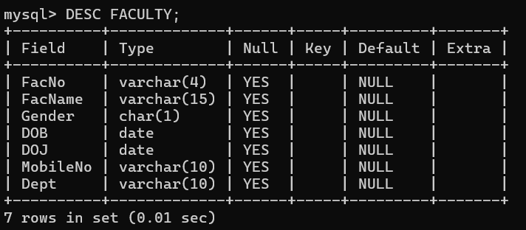

RESULT:
Tables are created, altered and modified using DDL commands.

